**Accounts Fourth time for reviewing!!**

1. In Account chart **not allow** AccountName_En to be repeated of adding new account
2. In Account chart **not allow** to delete any account which has actions or processes or journals to it.
3. In Account Chart in the gridView rows the (main Account rows ”first and Second levels ”

Like 1 or 11, 2,21, 3,31, 4,41 etc.) Should be in a specific colors.

1. In Account chart when add new Account please add dropBox contains 2 items (**Debit** and **Credit**) beside Open Balance textbox as a flag info. You will use in the General Ledger Report where you will but the Open Balance in (debit or credit ) columns.

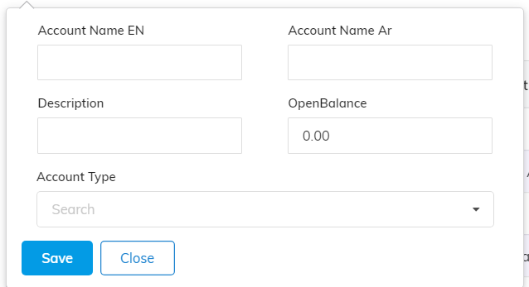

1. in the GRIDView AccountNameAR should be according to the (Arabic Configure icon) which show all hide the Ar fields from page and gridview.
2. In General it is a must to **not allow** to delete (Accounts, Bank ,client , supplier, ..etc ) if any action or process or journal registered to that item
3. Daily Journal Page:

* Cannot save a new one because Journal date cell error when click save
* Journal Type should not a mandatory “where is the form of Journal Types add/edit”
* Can edit the Refernce Number “get default as it is but allow Edit”

1. Ledger Report is not working

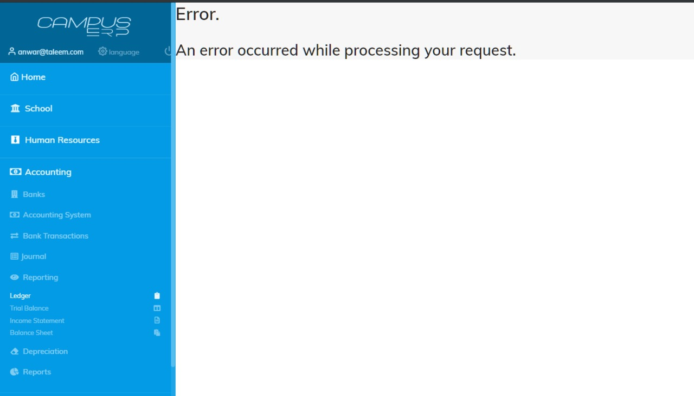

Should be contains Account and its details and processes start by Beginning Balance then actions then Ending Balance. Also **should be get in a period** (from ….. to ….)

Like which I sent previous:

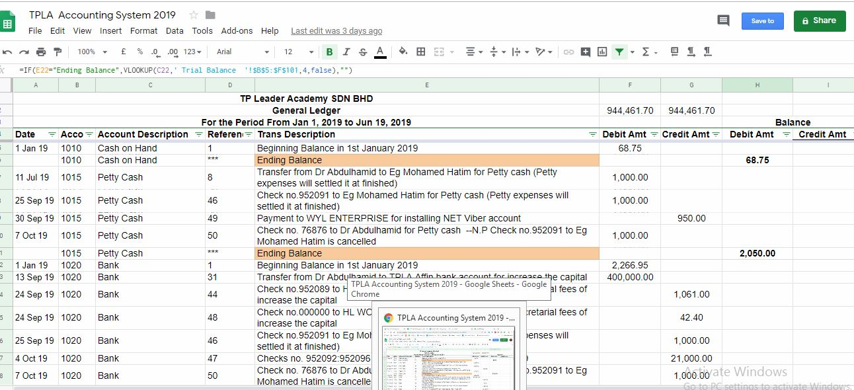

1. **Trial Balance Report** :

* Should issue in specific date (not a period)
* Show all the account chart in a gridview not is selecting a group from drobList as existing. Also can export.
* The report only Contains the accounts Balances values for debit or credit for all accounts
* Ending with Totals
* **Debit Amount** and **Credit amount** should be balanced in the last total of-course.

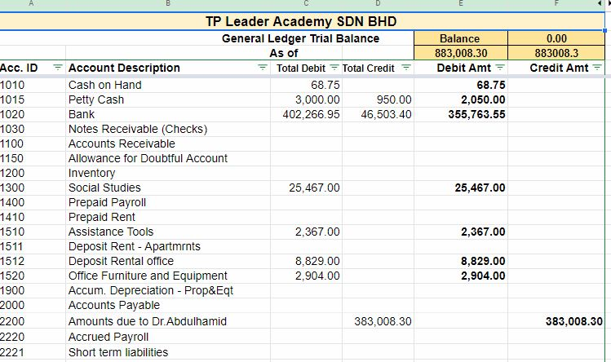

1. All Reports Pages should have Export (Excel + PDF) .

Ledger, Trial Balance, Income Statement and Balance Sheet

1. The icon of show Arabic fields should updated in all forms (Add/Edit) and Gridviews of entries.

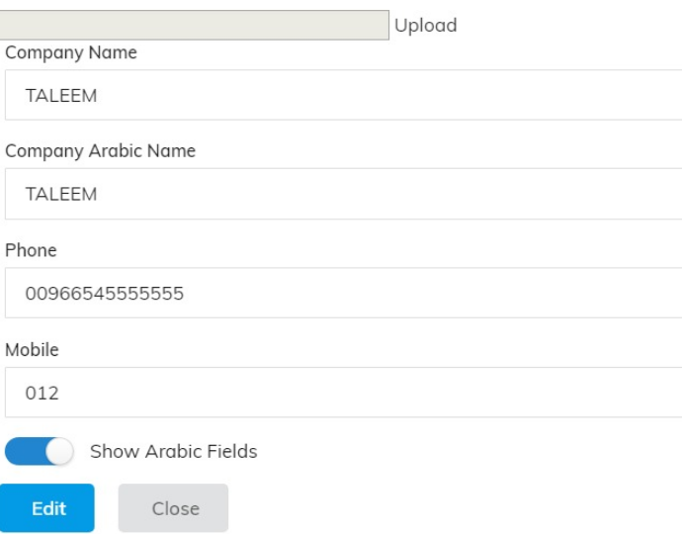

Please test that you apply on hide Arabic fields “in banks you apply for hide English fields !!”

1. In the Grade Fees Setup

* First installment droBox not show all items
* The final amount it was automatic calculated but now is stopped!!!

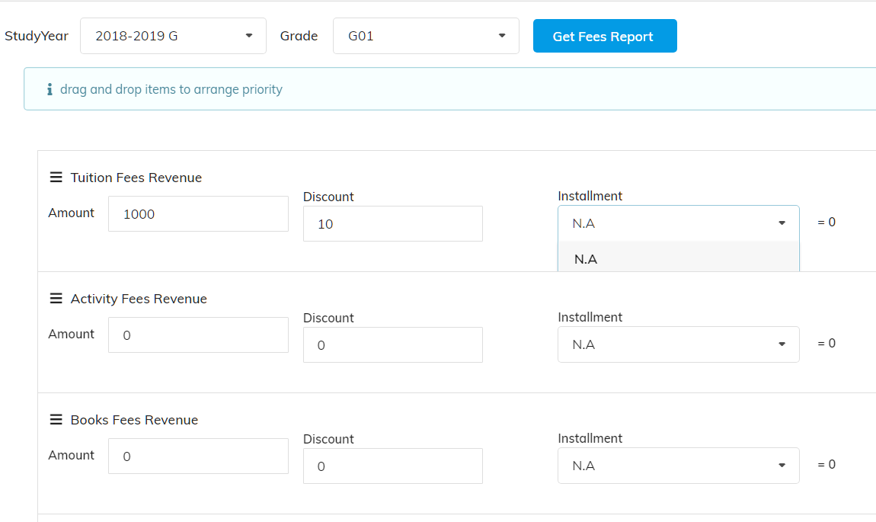

1. Left Menu (Extract/Hide) icon